Homework 3 E-R Model and Relational Data Model

1. Design a relational database corresponding to the E-R diagram of Figure 3.38.

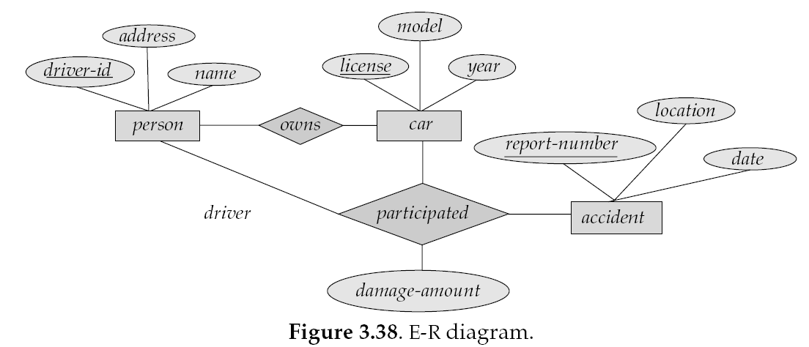

Note: all relationships are many-to-many

2. Design a generalization–specialization hierarchy for a motor-vehicle sales company.

The company sells motorcycles, passenger cars, vans, and buses.

Justify your placement of attributes at each level of the hierarchy. Explain why they should not be placed at a higher or lower level.

Write both ERD and relational model (in table format)